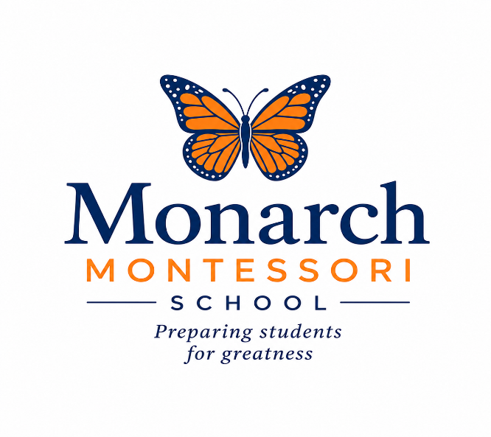
Application for Admission
Office Use Only:
Registration Fee $800 _________
Virginia Model Registration Form ________
Client Agreement ________
Report Cards (K-3) _______
Birth Certificate ________
1st Month’s Tuition Payment_______
Annual Activity Fee ($125) _________
Tuition Agreement _________
Emergency Evacuation Plan _________
Authorization to Seek Emergency Care ________
Health Information Forms _________
Parent Handbook __________
Fieldtrip Permission Form __________
Orientation Meeting w/Head of School ________

All required items must be submitted to complete the admissions process. Please complete the application below. If you are applying for more than one child, submit a separate application for each child. This application has three sections; please complete all sections and email the completed form to monarchmontessoridirector@gmail.com.
Your privacy is important to us. Your information will be added to our school’s secure database.

- CONTACT INFO
Child’s Name:_________________________________________________________________

Date of Birth: __________ Age at Admittance: ___________

Requested Start Date: ________________

Languages Spoken at Home: _____________________________________________________________

Siblings Enrolling at Monarch Montessori School? YES _______ NO _______
If yes, name(s) of sibling: __________________________________________________

Child’s Home Address: ________________________________________________________________________
Parent’s Name: _________________________________________________________
Cell Phone: ________________________
Occupation: _______________________________________
Work Phone: ________________________
Work Address: ________________________________________________________________________
Email: ____________________________________________
Parent’s Name: ________________________________________________________
Cell Phone: ________________________
Occupation: _______________________________________
Work Phone: ________________________

Work Address: _________________________________________________________
Email: ____________________________________________
Are you divorced? If so, does one parent have primary custody?
YES ______ NO _______
Which parent will be the primary pick-up and drop-off person?
Name: ________________________________________________________________

- PROGRAM
NOTE: Before admission, children ages 2 and older must attend two complimentary trial days at Monarch Montessori School. Trial days are held on Tuesdays and Thursdays from 8:00 a.m. to 12:00 p.m. During this time, children will be observed to assess their fit with our program, teaching staff, and classroom materials. Applications will be approved only after both trial days are completed.

At Monarch Montessori School, our programs are defined by the number of hours your child is in care. We offer 3 options. Please place a checkmark next to the option you are interested in.
Option 1: 8:00 AM to 5:30 PM ________
Option 2: 8:00 AM to 12:00 PM ________
Option 3: 8:00 AM to 5:30 PM 2 consecutive days of the week _________

We offer 2 auxiliary programs. Please place a checkmark next to the auxiliary program you’re interested in. Please revisit our website for our Back-up Care Application.

Mom’s Morning Out (Age 2-6 years)
8:00 AM to 11:00 AM _________

Summer Camp (Age 5-8 years)
9:00 AM to 3:00 PM _________

- QUESTIONS

We ask that you answer the following questions about your child. Please print legibly.

- Does your child have any physical conditions that require special accommodation?

- Does your child have any diagnosed mental health conditions?

- Does your child take any medications daily?

- Has your child had any prior school experience? If so, please list all schools below and dates of attendance below:

Name of School ____________________________________________________

Dates attended_________________________________________________

Name of School ____________________________________________________

Dates attended _________________________________________________

Name of School _____________________________________________________

Dates attended __________________________________________________

4(a). For K-3 applicants, please indicate last grade completed here:

_______________________

- Has your child ever been suspended or expelled from a childcare facility or K-3 school?

Yes______ No ________

5(a). If yes, please explain below.

5(b). What method(s) of discipline do you use at home?

- Has your child undergone any academic, diagnostic, psychological or other testing?

- Is your child currently working with a speech pathologist or other therapist during the school day?

- Has your child spent any time away from you?

- What are your child’s sleeping habits? Does your child sleep at night? Does he/she take naps during the day?

- Is your child potty-trained? Yes ______ No ________

- What are your child’s eating habits? Preferences? Food allergies?

- We advocate parent involvement. Would you be willing to come to school and do an activity with your child’s class? (cooking, art project, reading a book or anything else?)

- What activities does your child like to do?

- Does your child have siblings? Yes_________ No __________

- Is your child waitlisted at another school? If so, where?

- Why are you seeking a Montessori learning environment?

- How did you learn about our school?

Social Media __________

ALX Now Advertisement___________

Word of Mouth ___________

Back-Up Care ___________

Summer Camp ___________

Previously Enrolled ____________

VA Childcare Subsidy ___________

MCCYN Program/Department of Defense ______________

I saw the sign while driving/walking past the school ______________

- Why did you decide to choose Monarch Montessori School?

- Are you committed to at least one full year of enrollment/programming?

Thank You!

Monarch Montessori School is a for-profit, independent school with no religious affiliation. The school admits students of any race, color, religion, sexual orientation, national origin, or ethnic origin and provides equal access to all rights, privileges, programs, and activities available to students. Monarch Montessori School does not discriminate based on race, color, religion, sexual orientation, national origin, or ethnic origin in its educational policies, admissions policies, or other school-related programs.

Parent Signature: _________________________________________________________

Parent Signature: _________________________________________________________

Date: __________________

School Administrator’s Signature: ___________________________________________

Date: _________________

